POD|LCA Materials Tool

Quick Start Guide

Installation
- The code base is available at https://github.com/POD-LCA/pod_lca. It is a private repository. With read access you can download (or clone) the repository. (Cloning a repository with Git or a Git-client would allow you to pull changes whenever the updated versions are available, as opposed to downloading all files every time a software update is made)
- POD|LCA Material Tool is built using Python programming language, and using a few other dependent packages. You need to install the following list of packages along with Python.
- Python==3.11.9
- numpy==1.26.4
- scipy==1.14.0
- matplotlib==3.9.2
- pandas==2.2.2
(We may decide to create an installer for users later. Currently, we will resort to installing individual packages)
- Open windows command prompt and navigate to the folder ‘\pod_lca’. Once there, type ‘python -m GUI.gui’ and press enter. The POD|LCA Material Tool window will pop-up.

The Graphical User Interface (GUI)
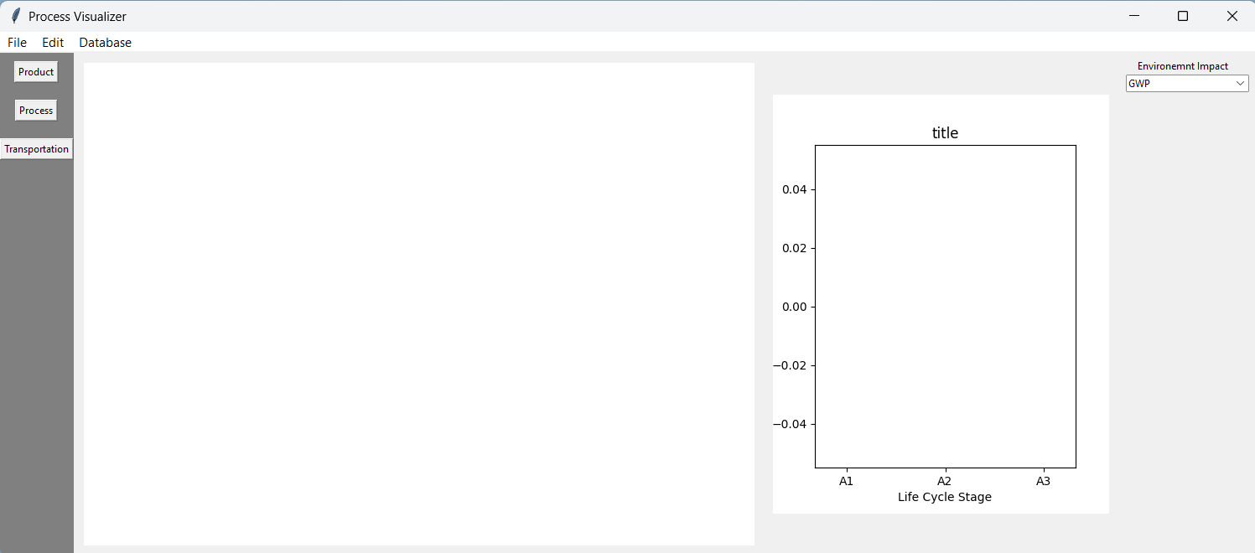
Palette
Canvas
Plotter
Menu bar

The graphical user interface (GUI) of the POD|LCA Material Tool has 4 main components: Menu bar, Palette, Canvas, and Plotter
- Menu bar:
- Canvas
- Palette
- Plotter

Create New Project
Not yet implemented. Opening the program directly opens the GUI, without a start-up wizard

Importing Impact Data

Creating Process Flow Chart

Visualizing Results

Developer Guide

Program structure

Class diagram

GitHub repository

Creating issues

Working on Branches
// how to create a branch

